Home Page

URL: <http://localhost:3000/>

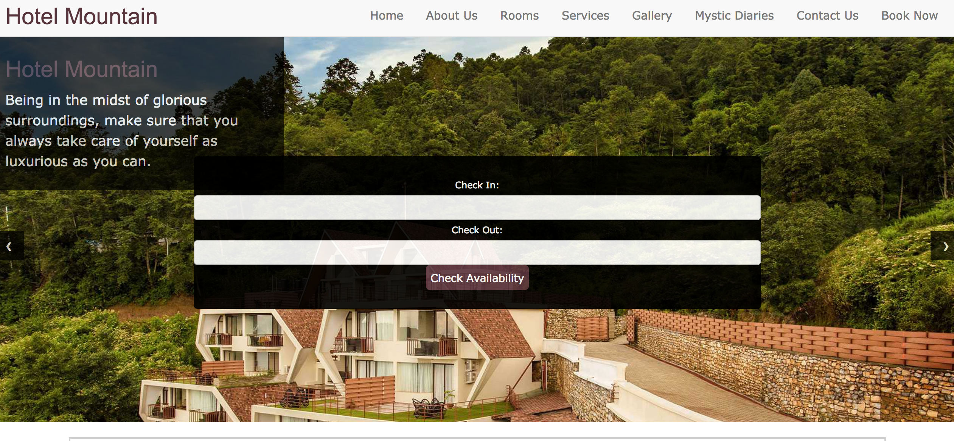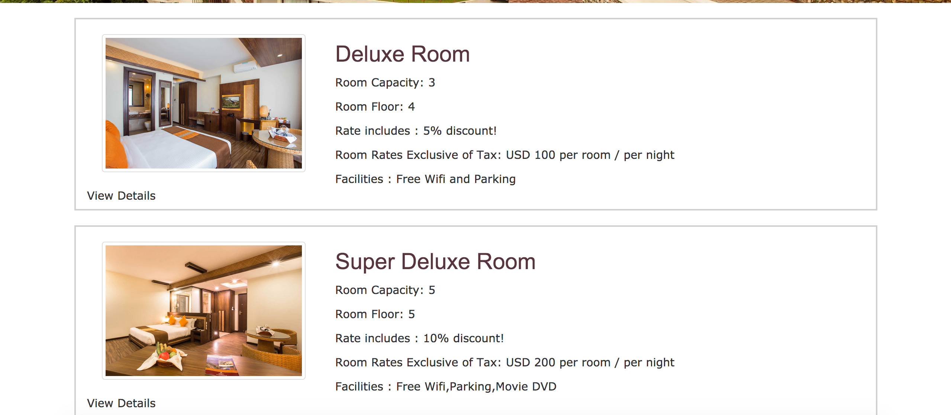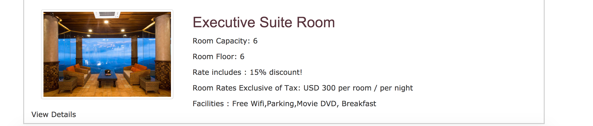

Search Room

URL: <http://localhost:3000/>

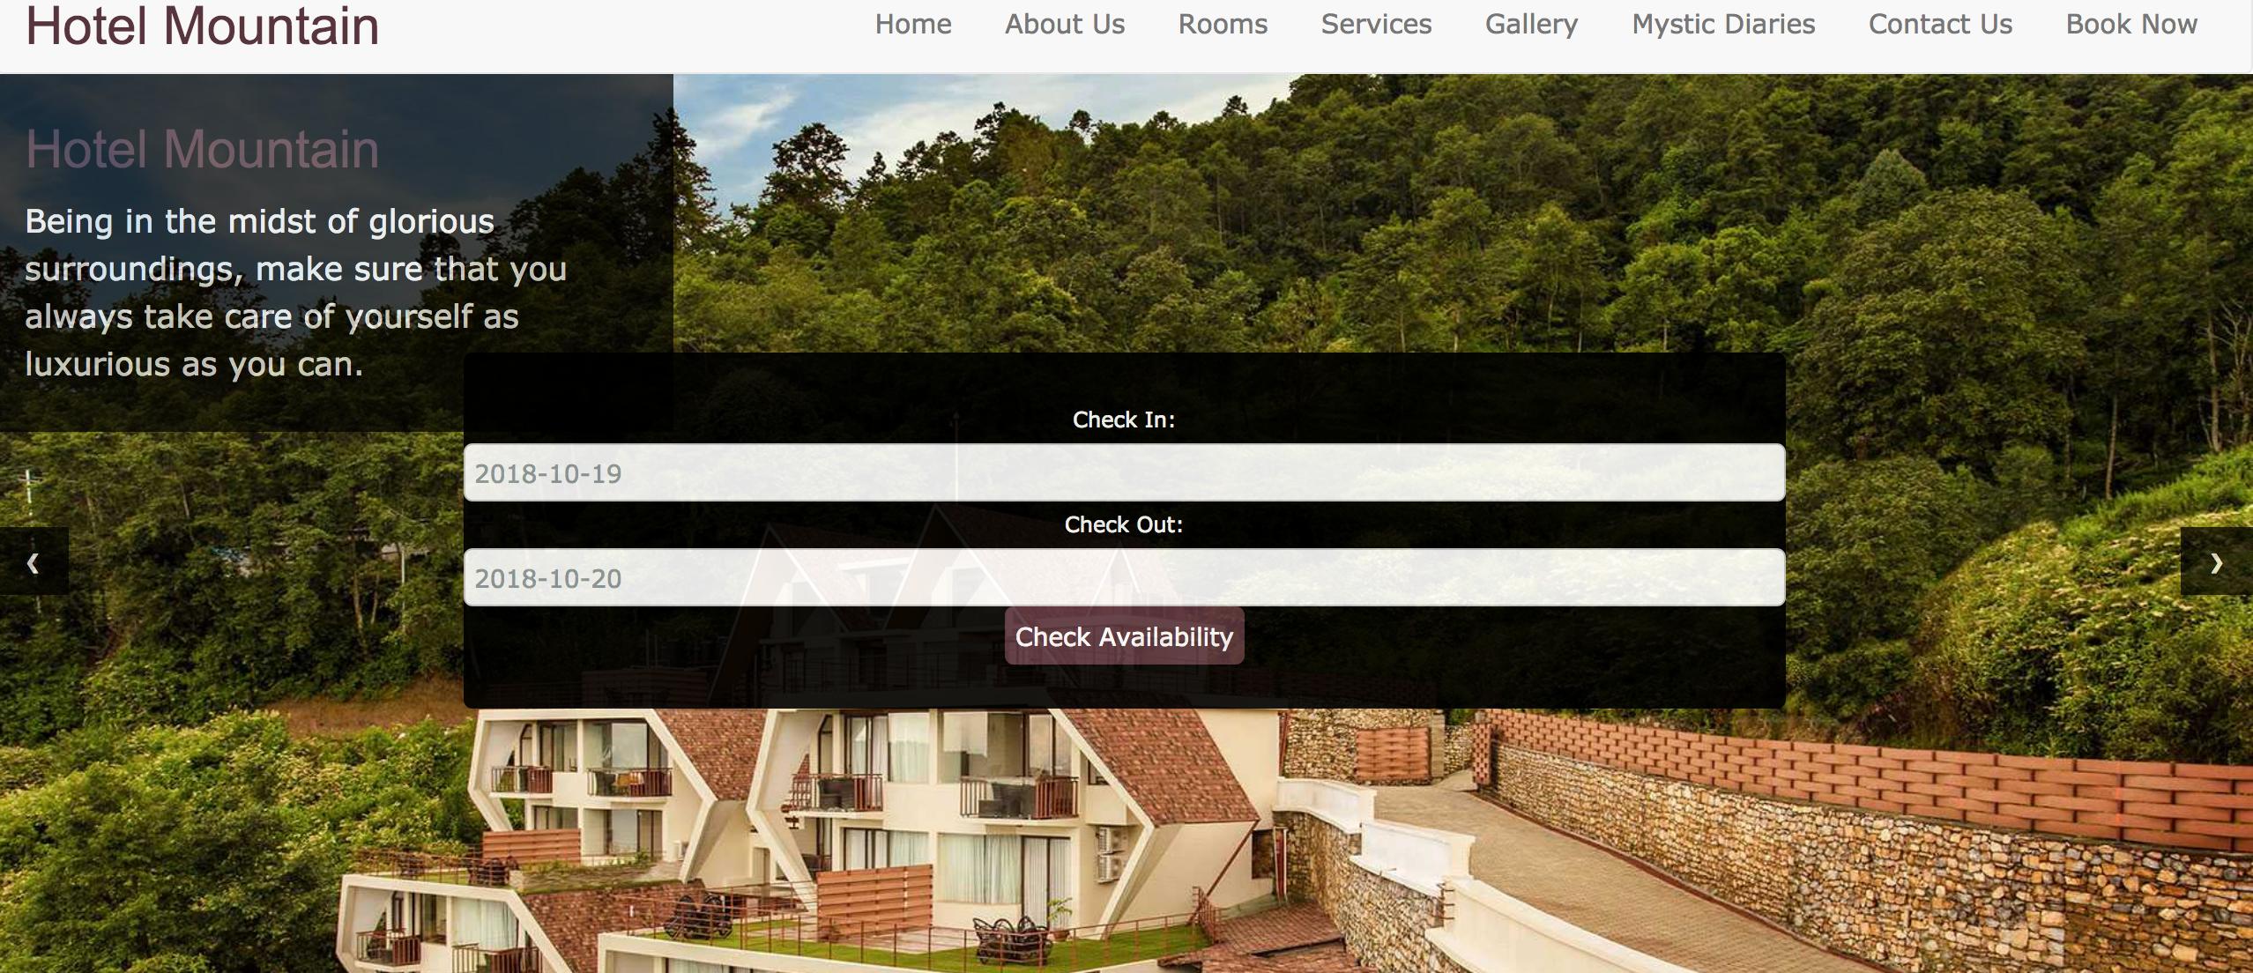

Display results based on availability

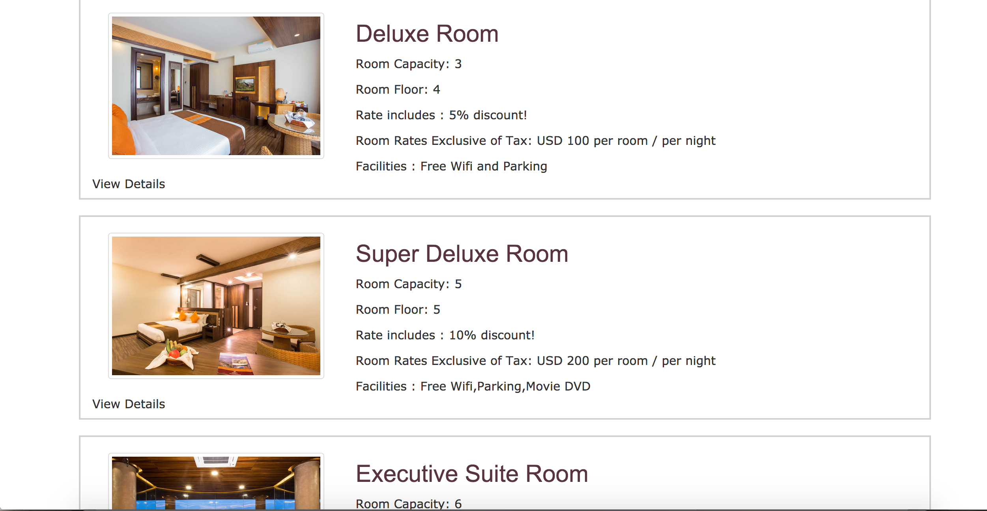

Click on ‘View Details’ to view room detai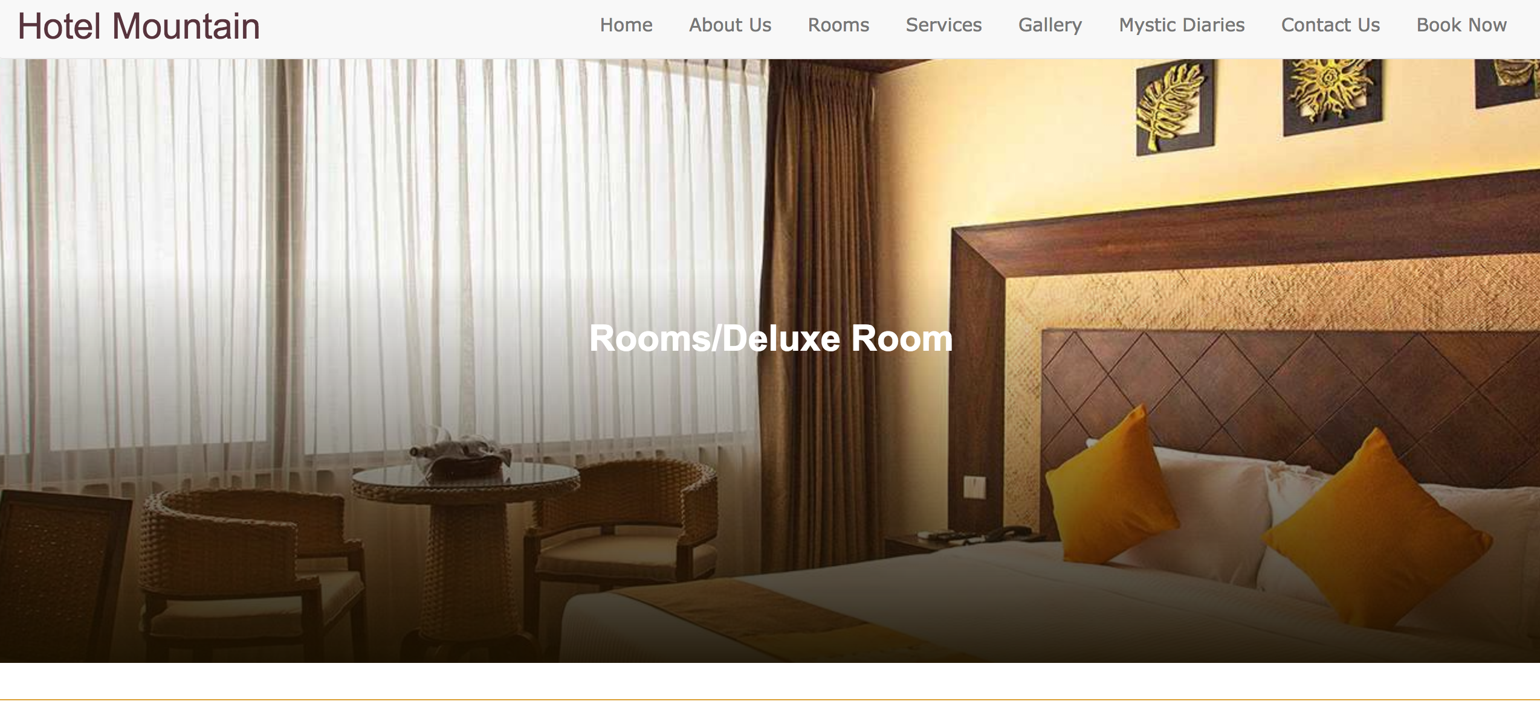l information

URL:- <http://localhost:3000/type/1>

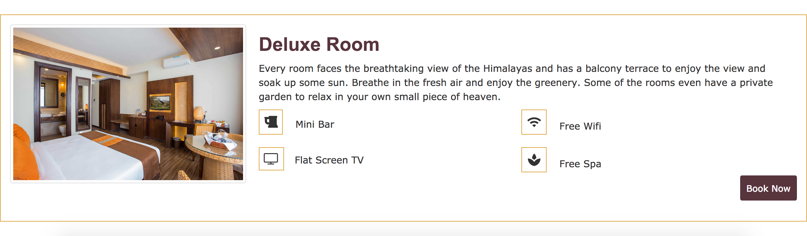

Click ‘Book Now’ to book the particular room

URL :- <http://localhost:3000/registration/type/1>

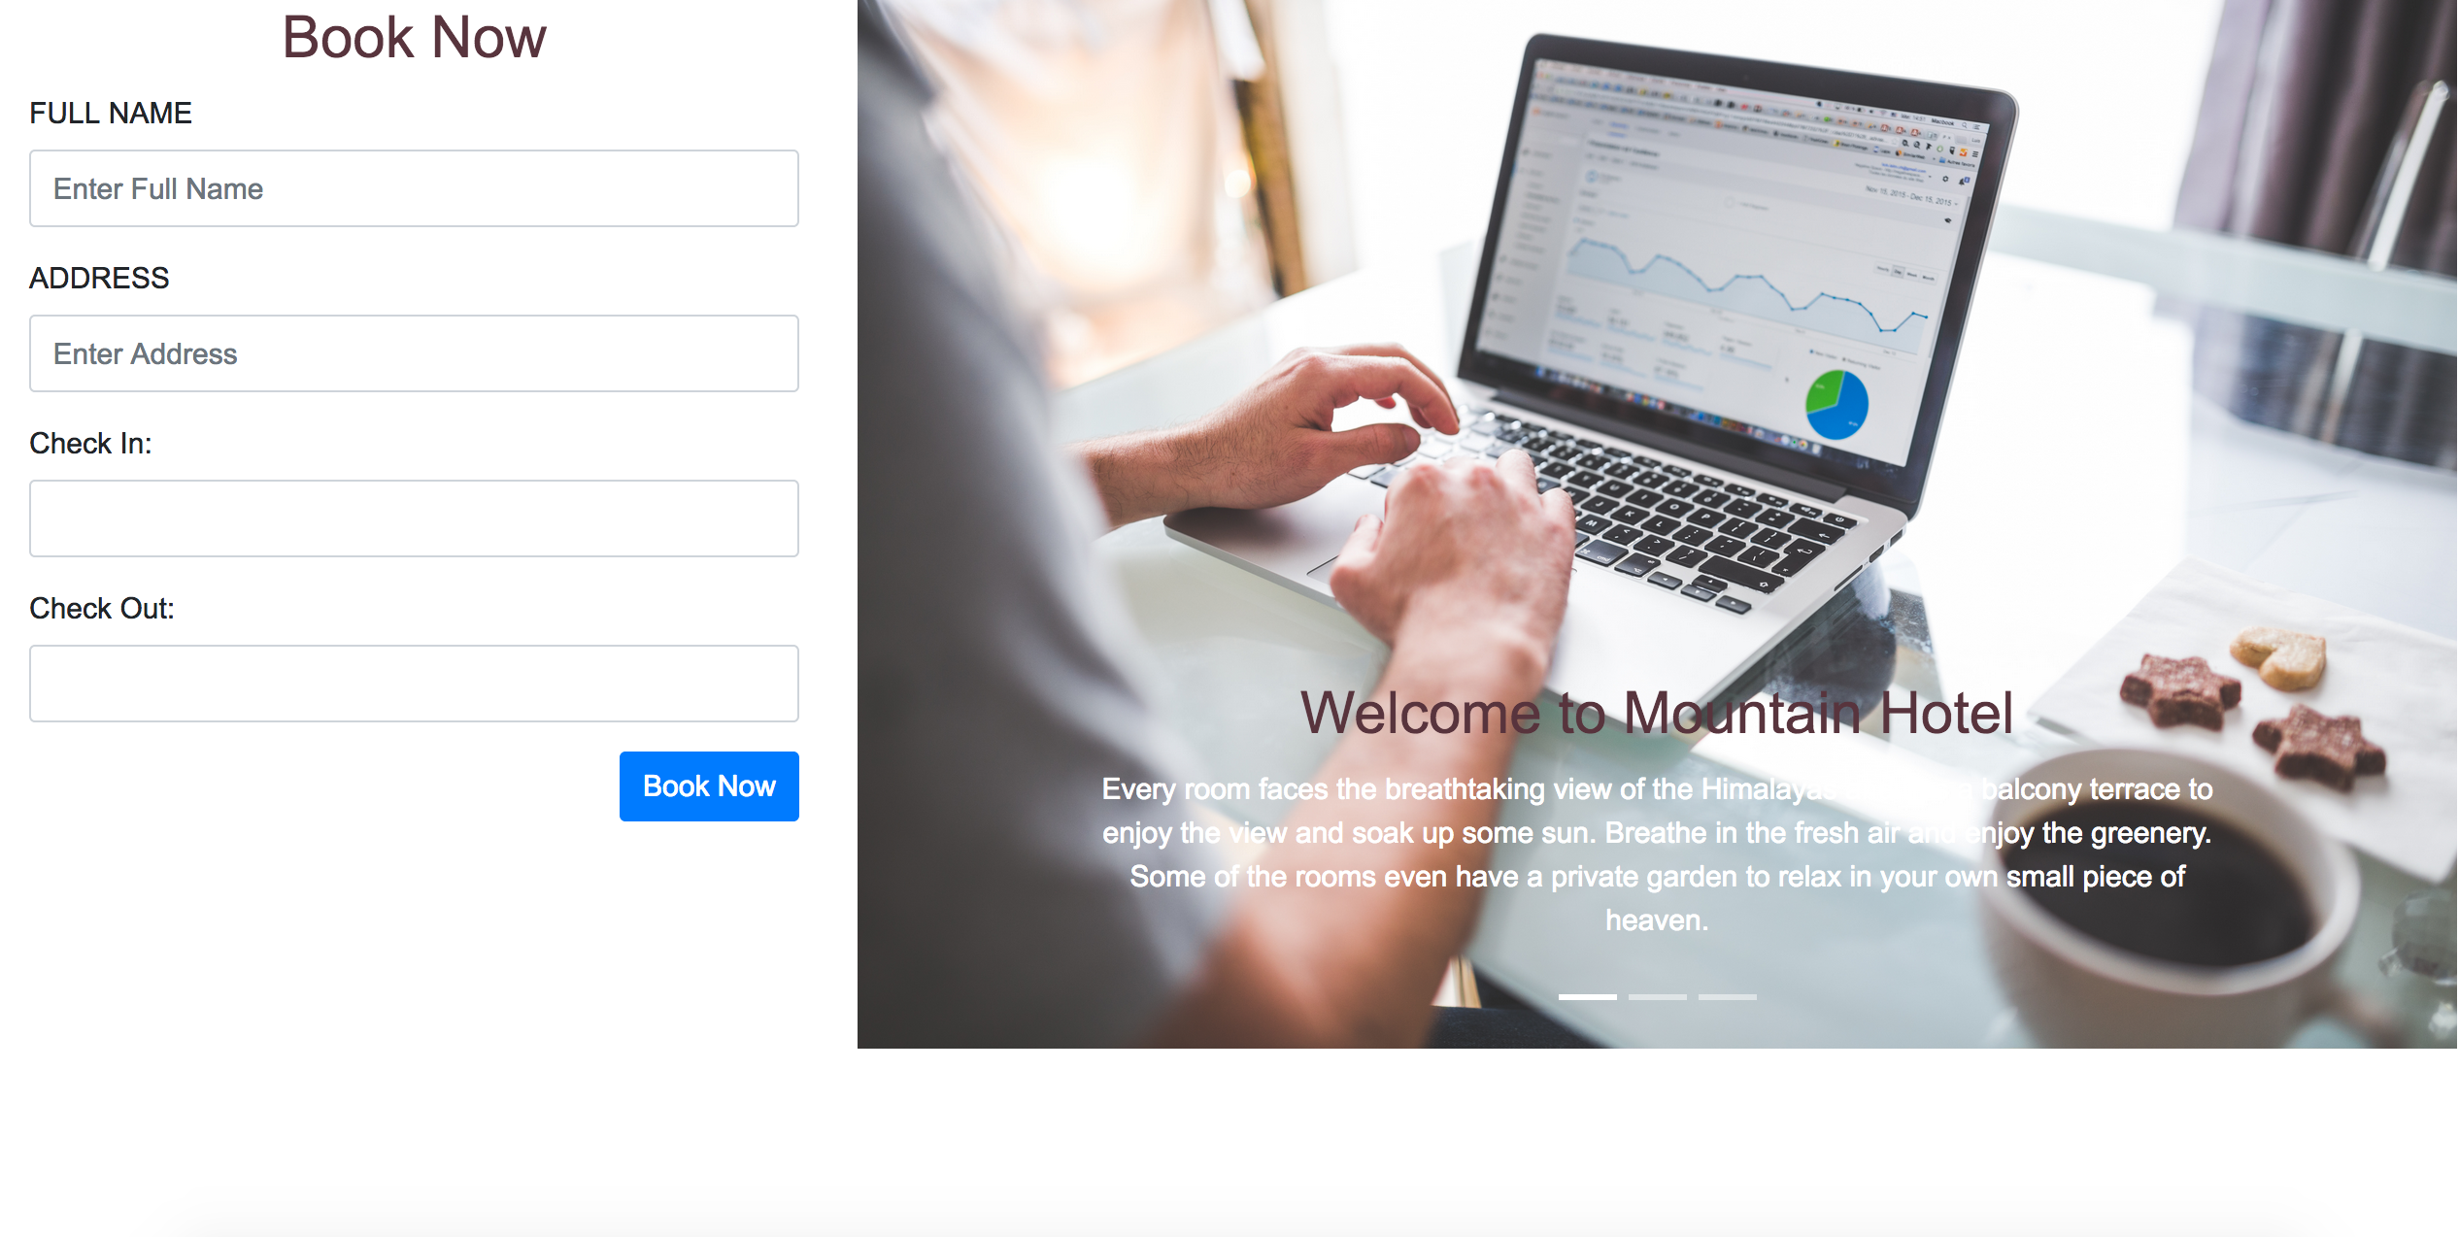

Fill up the personal information

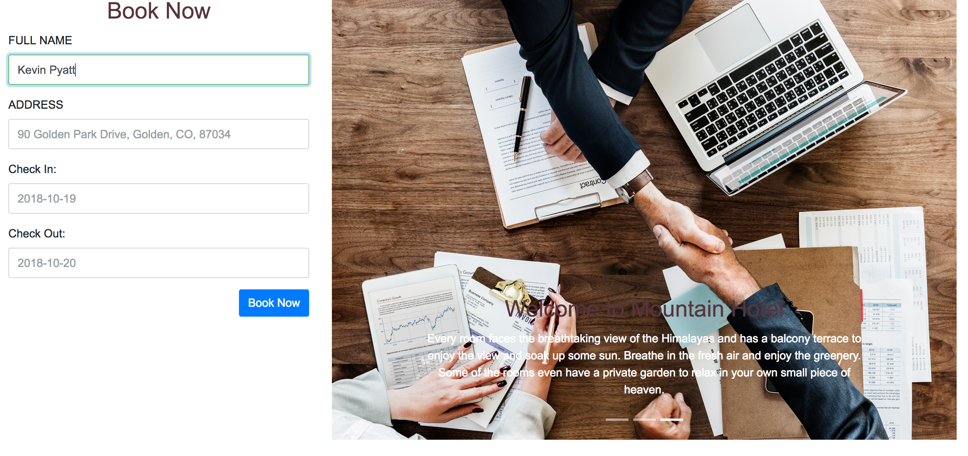

Confirmation Page

URL :- <http://localhost:3000/confirm>

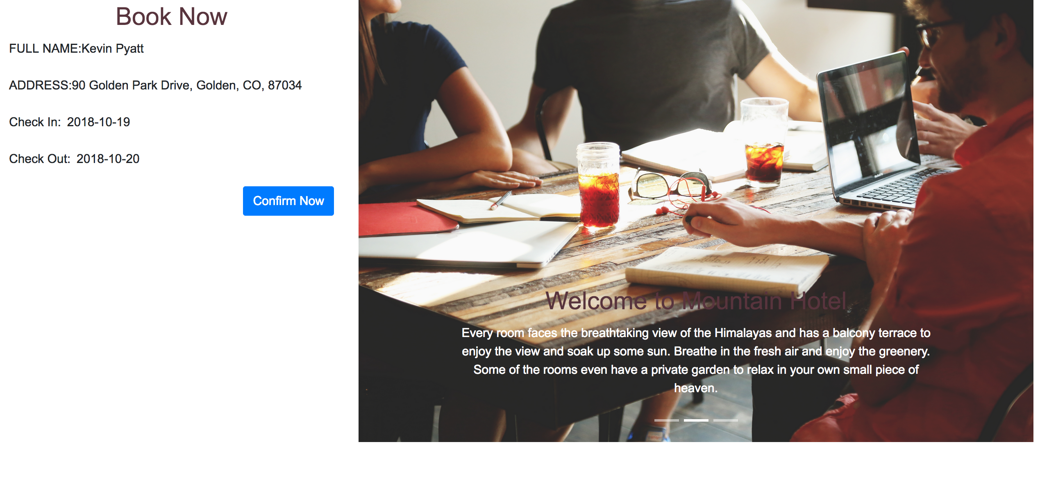

Click on the ‘Confirm Now’ button to book the room and confirm message will display.

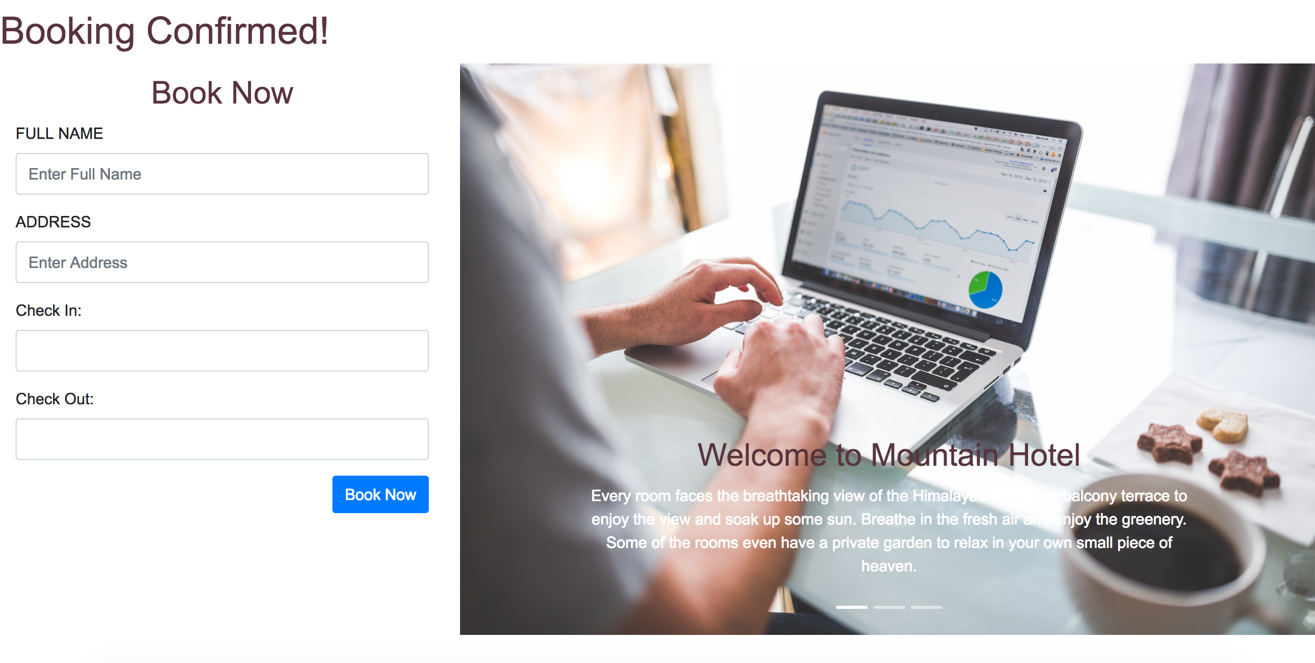

Database Design:-

Total 7 Collections

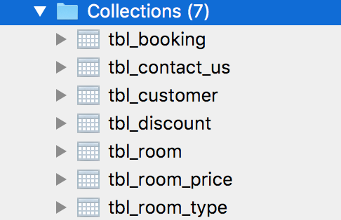

tbl_booking

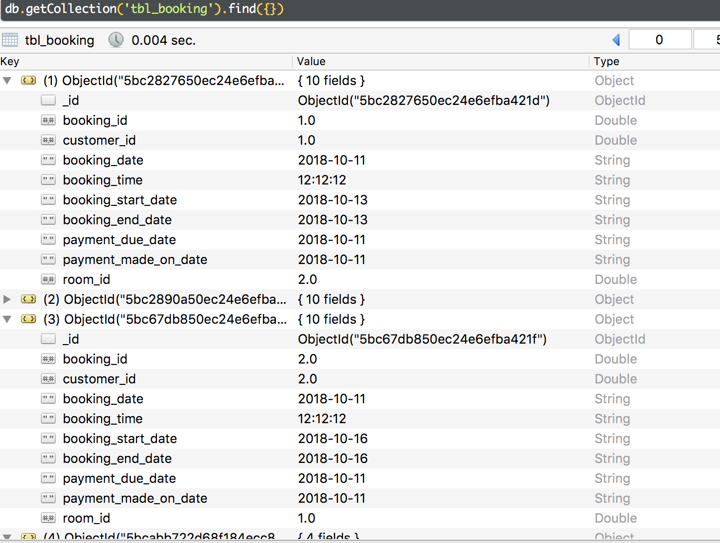

tbl_contact_us

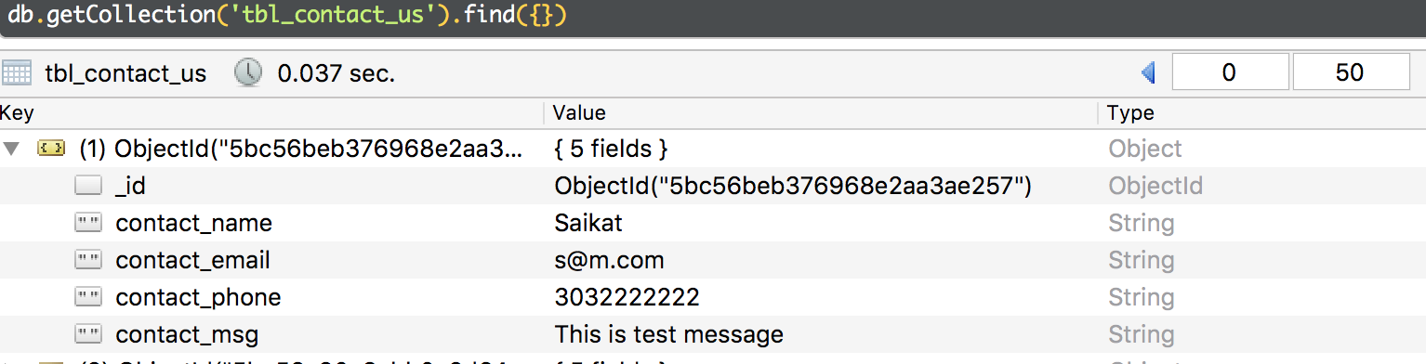

tbl_customer

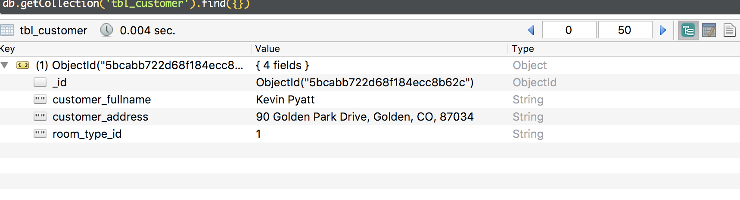

tbl_discount

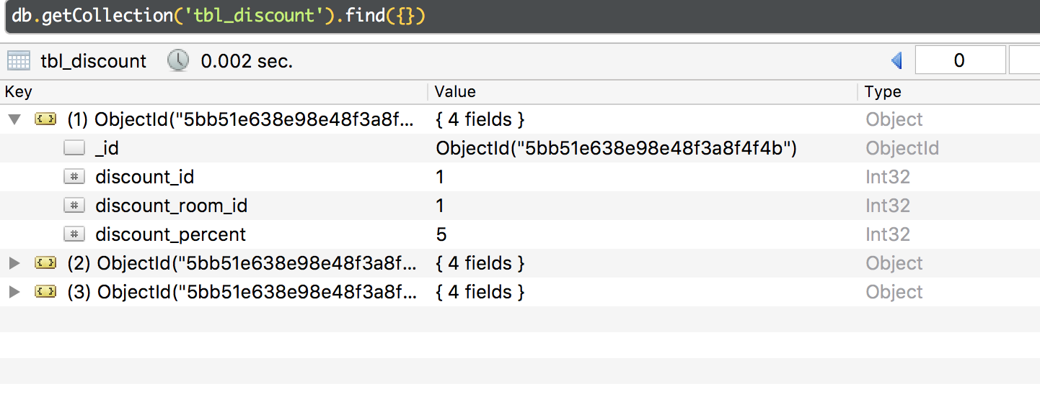

tbl_room

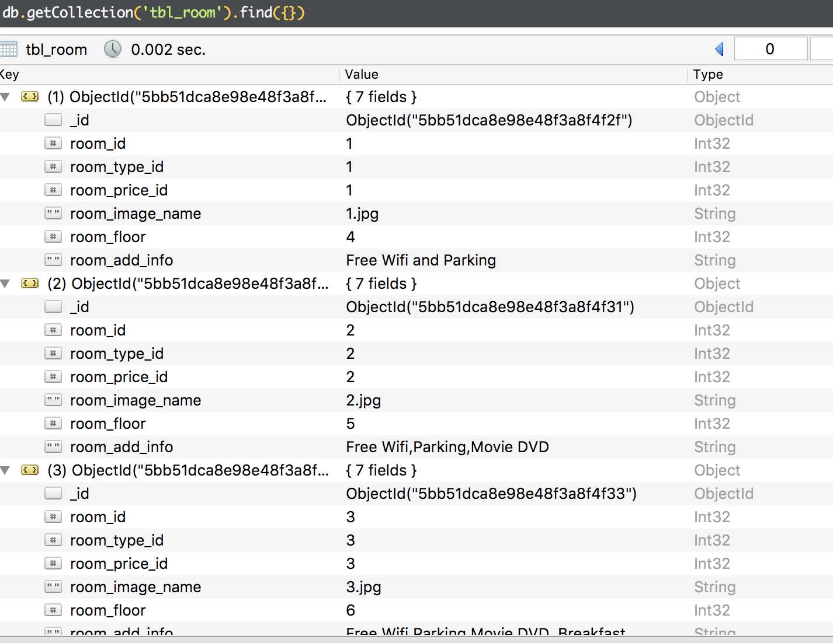

tbl_room_price

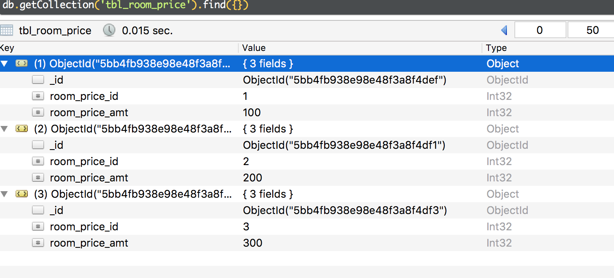

tbl_room_type

